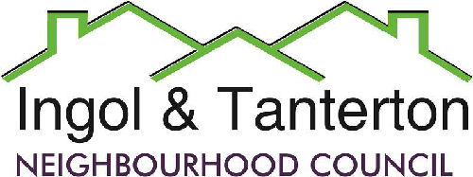
Gill Mason - Clerk and RFO
Email: ingoltantertonnc@hotmail.co.uk
Agenda
All parish councillors are hereby summoned to the meeting of the Ingol and Tanterton Neighbourhood Council on Wednesday 17th April 2024 at 7.00pm at Tanterton Village Centre.

Open forum

1.To receive apologies.

2.To approve the minutes of the meeting held on Wednesday 20th March 2024.

3.To receive declarations of interest.

4.To consider planning applications, reports and matters.

5.Finance.
Expenditure
BACS | MB Landscaping | Lengthsman’s basic | £624.00
BACS | Gill Mason – clerk | Monthly expenses | £23.24
BACS | TVC | Grant | £6250.00
BACS | Intact | Grant | £10,000.00
BACS | TVC | Youth Worker project grant | £2125.00
BACS | British Gas | Cottam Gate electrics | £34.75
BACS | LALC | Subscription | £857.74
BACS | Tidy Town Competition | Fees | £50.00

6.To consider the lengthsman’s update and schedule of works.

7.To consider the green spaces agreement with Preston City Council and review the schedule.

8.To consider the update on the Ingol Dip area, playpark project and asset acquisition/land transfer to the neighbourhood council.

9.To consider and approve the AGAR 2024 and to appoint an internal auditor,

10.Reports and correspondence.

11.Date and time of meetings.

Press and public are welcome to attend.

